PERSONAL PARTICULARS |  |  |  |  |  |  |  |  |  |  |  |  |  |  |  | CARETAKER
姓名  NAME | LAURA JEAN J. ANITO |  |  |  |  |  |  |  |  |  |  |  |  |  |  |  |  |  |  |  | J-005
地址  ADDRESS | 1893 DALANDAN ST. AREA D. CAMARIN CALOOCAN CITY |  |  |  |  |  |  |  |  |  |  |  |  |  |  |  | 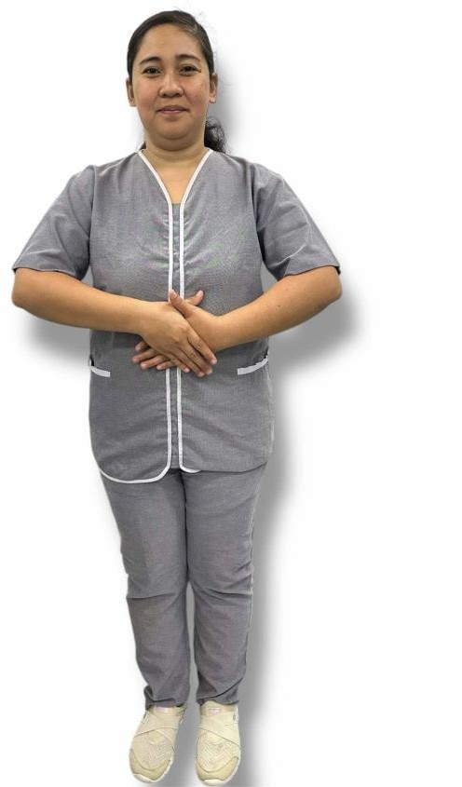
年齡  AGE –  33YRS. OLD | 占星術  Horoscope |  |  |  |  |  | ARIES | 出生日期  BIRTH DATE |  |  | APRIL 02,1992
性別  SEX | FEMALE |  |  |  |  |  |  | 出生地點  PLACE OF BIRTH |  |  | TONDO, MANILA CITY
國籍  NATIONALITY | FILIPINO |  |  |  |  |  |  | 宗教信仰  RELIGION |  |  | ROMAN CATHOLIC
身高  HEIGHT (CM) | 157 |  |  |  |  |  |  | 體重  WEIGHT (KG) |  |  | 68
特別技能  SKILL |  |  |  |  |  |  |  |  |  |  |  |  |  |  |  |  | 語言  LANGUAGE |  |  |  |  | ENGLISH/ TAGALOG
婚姻狀況  CIVIL STATUS |  |  |  |  | 未婚  SINGLE |  |  | X |  | 已婚  MARRIED |  |  |  |  | 離異  SEPARATED |  |  |  |  |  |  | 寡居  WIDOWED
教育程度  EDUCATION |  |  |  |  | 小學  ELEMENTARY |  |  |  |  | 中學  HIGHSCHOOL |  |  | X |  | 大學  COLLEGE |  |  |  |  |  |  | 專科  VOCATIONAL
學校名稱  NAME OF SCHOOL LAST ATTENDED |  |  |  |  |  |  |  | CHS-CIELITO ZAMORA HIGH SCHOOL ANNEX II
主修 COURSE
練習 TRAINING
國內經歷 LOCAL EMPLOYMENT RECORD
工作期間  Month / day / year  From ---  To |  |  | 雇主  EMPLOYER |  |  |  |  |  | 職務  JOB TITLE
國外經歷 OVERSEAS EMPLOYMENT RECORD
工作期間  Month / day / year  From ---  To |  | 國家 COUNTRY  雇主 EMPLOYER |  |  |  |  |  |  | 職務  JOB TITLE
2023-2024 |  | TAIWAN |  |  |  |  |  |  | CARETAKER
REMARKS: CAN COOK, CAN TAKE CARE ELDER AND DOING HOUSEHOLD CHORES.
PASSPORT |  |  |  | TRAINING |  |  |  |  | UMID |  | NBI |  |  | MEDICAL |  |  |  | TRAVEL HISTORY
P6513712B |  |  |  |  |  |  |  |  | 34210  71602
CONTACT NUMBER: 09163032704
FACEBOOK ACCOUNT: AZHEN JATICO

FAMILY BACKGROUND 家 庭 狀 況
親屬關係  Relation | 姓名  Name | 年齡  Age | 職業  Occupation | 備註  Remarks
父親 Father | MANUEL ANITO | 63
母親 Mother | JOCELYN ANITO | 54
配偶 Spouse
其他 Others /  CHILDREN’s | NATHANIEL DAVE A. CAUAN NATHALY DAVE A. CAUAN NOREEN DENISE A. CAUAN | 13  10  07 | STUDENT

DATE APPLIED: MAY 08,2025

