PERSONAL PARTICULARS

CARETAKER

姓名  NAME | MARICRIS PRIOLO TENORIO |  |  |  |  |  |  |  |  |  |  |  |  |  |  |  |  |  |  |  | H-755
地址  ADDRESS | BRGY. MANGGAHAN DOLORES QUEZON |  |  |  |  |  |  |  |  |  |  |  |  |  |  |  |  | 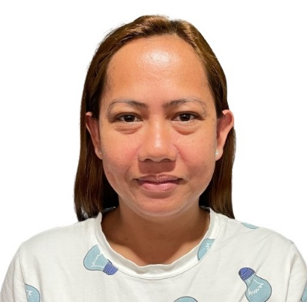
年齡  AGE –39 | 占星術  Horoscope |  |  |  |  |  |  | 出生日期  BIRTH DATE |  |  |  |  | APRIL 17, 1985
性別  SEX | FEMALE |  |  |  |  |  |  | 出生地點  PLACE OF BIRTH |  |  |  |  | TAYABAS QUEZON
國籍  NATIONALITY | FILIPINO |  |  |  |  |  |  | 宗教信仰  RELIGION |  |  |  |  | CATHOLIC
身高  HEIGHT (CM) | 157 |  |  |  |  |  |  | 體重  WEIGHT (KG) |  |  |  |  | 57
特別技能  SKILL | HARDWORKING |  |  |  |  |  |  |  |  |  |  |  |  |  |  |  |  | 語言  LANGUAGE |  |  |  | ENGLISH/ TAGALOG
婚姻狀況  CIVIL STATUS |  |  |  |  | 未婚  SINGLE |  |  |  |  |  | 已婚  MARRIED |  |  |  |  |  | 離異  SEPARATED |  |  |  |  | 寡居  WIDOWED
教育程度  EDUCATION |  |  |  |  | 小學  ELEMENTARY |  |  |  |  |  | 中學  HIGHSCHOOL |  |  |  |  |  | 大學  COLLEGE |  |  |  |  | 專科  VOCATIONAL
學校名稱  NAME OF SCHOOL LAST ATTENDED |  |  |  |  |  |  |  | LIWAYWAY NATIONAL HIGH SCHOOL
主修 COURSE |  |  |  |  |  |  |  |  |  |  |  |  |  | 
練習 TRAINING

國 內 經 歷 LOCAL EMPLOYMENT RECORD
工作期間  Month / day / year  From --- To |  |  | 雇主  EMPLOYER |  |  |  |  |  | 職務  JOB TITLE

國 外 經 歷 OVERSEAS EMPLOYMENT RECORD
工作期間  Month / day / year  From --- To |  | 國家COUNTRY  雇主EMPLOYER |  |  |  |  |  |  | 職務  JOB TITLE
2023-2024 |  | HONG KONG |  |  |  |  |  |  | DOMESTIC HELPER
TAKING CARE OF ELDERLY, I KNOW HOW TO COOK, DO HOUSEHOLD CHORES.
PASSPORT |  |  |  | TRAINING |  |  |  |  |  | UMID |  | NBI |  |  |  | MEDICAL |  |  | TRAVEL HISTORY
OK |  |  |  |  |  |  |  |  |  | OK |  | OK
CONTACT NUMBER: 09122130572
FACEBOOK ACCOUNT:

FAMILY BACKGROUND 家 庭 狀 況
親屬關係Relation | 姓 名  Name | 年齡  Age | 職業  Occupation | 備註  Remarks
父親Father | CELSO PRIOLO | 74 | VENDOR
母親Mother | LORNA PRIOLO | 70 | HOUSEWIFE
配偶Spouse | LEO TENORIO
其他Others /  CHILDREN’s | ANDREY TENERIO  ALLIAH TENERIO  ADRIELLE ASHER TENORIO | 17  15  2 | STUDYING  STUDYING  N/A

DATE APPLIED:

