PERSONAL PARTICULARS
 | CARETAKER |  | MS

姓名  NAME | KRISTINE MARIE RAMORAN DE GUZMAN |  |  |  |  |  |  |  |  |  |  |  |  |  |  |  |  |  |  |  |  | H-674
地址  ADDRESS | 404 GUMAMELA ST. TORSITE B. TOWNSITE, MARIVELES BATAAN |  |  |  |  |  |  |  |  |  |  |  |  |  |  |  |  |  | 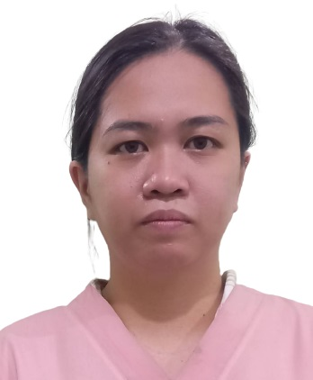
年齡  AGE – 30 | 占星術  Horoscope |  |  |  |  |  |  |  | 出生日期  BIRTH DATE |  |  |  |  | JUNE 14, 1992
性別  SEX | FEMALE |  |  |  |  |  |  | 出生地點  PLACE OF BIRTH |  |  |  |  |  | MARIVELES BATAAN
國籍  NATIONALITY | FILIPINO |  |  |  |  |  |  | 宗教信仰  RELIGION |  |  |  |  |  | METHODIST
身高  HEIGHT (CM) | 158 |  |  |  |  |  |  | 體重  WEIGHT (KG) |  |  |  |  |  | 58
特別技能  SKILL | HARDWORKING |  |  |  |  |  |  |  |  |  |  |  |  |  |  |  |  |  | 語言  LANGUAGE |  |  |  | ENGLISH/ TAGALOG
婚姻狀況  CIVIL STATUS |  |  |  |  | 未婚  SINGLE |  |  |  |  |  |  | 已婚  MARRIED |  |  |  |  |  | 離異  SEPARATED |  |  |  |  | 寡居  WIDOWED
教育程度  EDUCATION |  |  |  |  | 小學  ELEMENTARY |  |  |  |  |  |  | 中學  HIGHSCHOOL |  |  |  |  |  | 大學  COLLEGE |  |  |  |  | 專科  VOCATIONAL
學校名稱  NAME OF SCHOOL LAST ATTENDED |  |  |  |  |  |  |  | POLYTECHNIC UNIVERSITY OF THE PHILIPPINES
主修 COURSE |  |  |  |  |  | BACHELOR OF SCIENCE IN BUSINESS ADMINISTRATION |  |  |  |  |  |  |  |  | 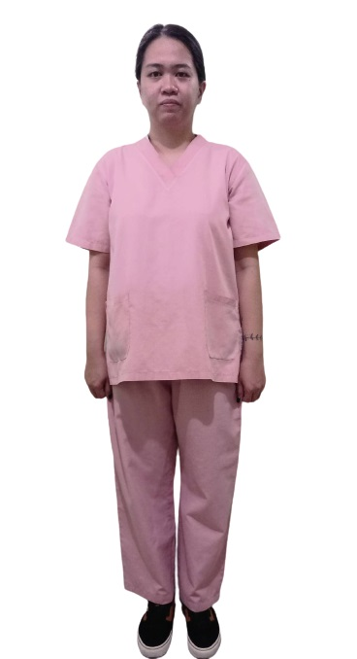
練習 TRAINING

國 內 經 歷 LOCAL EMPLOYMENT RECORD
工作期間  Month / day / year  From --- To |  |  | 雇主  EMPLOYER |  |  |  |  |  |  | 職務  JOB TITLE
2012-2012 |  |  | MITSUMI PHILIPPINES |  |  |  |  |  |  | Factory Worker
2015-2016 |  |  | KAIDEN’S STORE |  |  |  |  |  |  | CASHIER
2019-2021 |  |  | AAC TWINS CANTEEN |  |  |  |  |  |  | CASHIER
2021-2022 |  |  | MITSUMI PHILIPPINES |  |  |  |  |  |  | SOLDERING
2022-2023 |  |  | MMA COMPETENT |  |  |  |  |  |  | STAFF
2023-PRESENT |  |  | ERIN MARTY |  |  |  |  |  |  | CARETAKER (taking care of elderly, clean the house, ironing, washing clothes, Go to market)

國 外 經 歷 OVERSEAS EMPLOYMENT RECORD
工作期間  Month / day / year  From --- To |  | 國家COUNTRY  雇主EMPLOYER |  |  |  |  |  |  |  | 職務  JOB TITLE
WILLING TO TAKE CARE A BABY OR KIDS, I HAVE AN EXPERIENCE IN TAKING CARE OF BABY.
PASSPORT |  |  |  | TRAINING |  |  |  |  |  |  | UMID |  | NBI |  |  |  | MEDICAL |  |  | TRAVEL HISTORY
OK |  |  |  |  |  |  |  |  |  |  | OK |  | OK
CONTACT NUMBER: 09212674470
FACEBOOK ACCOUNT:

FAMILY BACKGROUND 家 庭 狀 況
親屬關係Relation | 姓 名  Name | 年齡  Age | 職業  Occupation | 備註  Remarks
父親Father | ROLANDO DE GUZMAN | 57 | DRIVER
母親Mother | CRISTINA DE GUZMAN | 58 | TEACHER’S AIDE
配偶Spouse
其他Others /
CHILDREN’s

DATE APPLIED: ____JANUARY 13, 2023_______

