PERSONAL PARTICULARS

CARETAKER

姓名  NAME | ROVAH SOLBITA |  |  |  |  |  |  |  |  |  |  |  |  |  |  |  |  |  |  |  |  | H 702
地址  ADDRESS | 149 PUROK 5, BRGY. LAPIDARIO TRECE MARTINES, CAVITE |  |  |  |  |  |  |  |  |  |  |  |  |  |  |  |  |  | 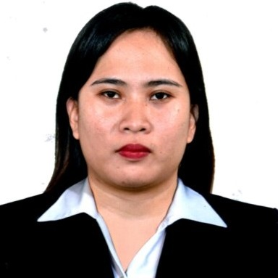
年齡  AGE – 29 | 占星術  Horoscope |  |  |  |  |  |  |  | 出生日期  BIRTH DATE |  |  |  |  | SEPTEMBER 20, 1995
性別  SEX | FEMALE |  |  |  |  |  |  | 出生地點  PLACE OF BIRTH |  |  |  |  |  | TRECE MARTIRES
國籍  NATIONALITY | FILIPINO |  |  |  |  |  |  | 宗教信仰  RELIGION |  |  |  |  |  | ROMAN CATHOLIC
身高  HEIGHT (CM) | 152 |  |  |  |  |  |  | 體重  WEIGHT (KG) |  |  |  |  |  | 60
特別技能  SKILL | HARDWORKING |  |  |  |  |  |  |  |  |  |  |  |  |  |  |  |  |  | 語言  LANGUAGE |  |  |  | ENGLISH/ TAGALOG
婚姻狀況  CIVIL STATUS |  |  |  |  | 未婚  SINGLE |  |  |  |  |  |  | 已婚  MARRIED |  |  |  |  |  | 離異  SEPARATED |  |  |  |  | 寡居  WIDOWED
教育程度  EDUCATION |  |  |  |  | 小學  ELEMENTARY |  |  |  |  |  |  | 中學  HIGHSCHOOL |  |  |  |  |  | 大學  COLLEGE |  |  |  |  | 專科  VOCATIONAL
學校名稱  NAME OF SCHOOL LAST ATTENDED |  |  |  |  |  |  |  | TRECE MARTIRES CITY NATIONAL HIGH SCHOOL
主修 COURSE |  |  |  |  |  |  |  |  |  |  |  |  |  |  | 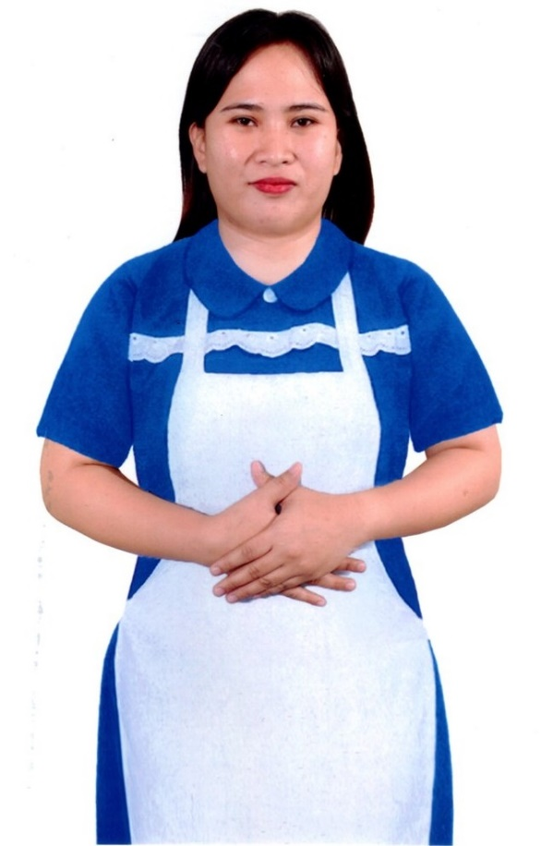
練習 TRAINING

國 內 經 歷 LOCAL EMPLOYMENT RECORD
工作期間  Month / day / year  From --- To |  |  | 雇主  EMPLOYER |  |  |  |  |  |  | 職務  JOB TITLE
07-11-2016  04-15-2018 |  |  | NHK |  |  |  |  |  |  | CARETAKER
05-10-2019  10-16-2023 |  |  | RS |  |  |  |  |  |  | TAKING CARE OF GRANDPARENTS

國 外 經 歷 OVERSEAS EMPLOYMENT RECORD
工作期間  Month / day / year  From --- To |  | 國家COUNTRY  雇主EMPLOYER |  |  |  |  |  |  |  | 職務  JOB TITLE
PASSPORT |  |  |  | TRAINING |  |  |  |  |  |  | UMID |  | NBI |  |  |  | MEDICAL |  |  | TRAVEL HISTORY
OK |  |  |  |  |  |  |  |  |  |  | OK |  | OK
CONTACT NUMBER: 09632409180
FACEBOOK ACCOUNT: ROVAH SOLBITA

FAMILY BACKGROUND 家 庭 狀 況
親屬關係Relation | 姓 名  Name | 年齡  Age | 職業  Occupation | 備註  Remarks

父親Father
母親Mother | CARMELITA SOLBITA | 60 | HOUSEWIFE
配偶Spouse
其他Others /
CHILDREN’s

