Unit 201 Estrella Condominium 858 San Andres St. Brgy 725 Malate, Manila

PERSONAL PARTICULARS

CARETAKER

姓名  NAME | MARY JOY E. BANTAD |  |  |  |  |  |  |  |  |  |  |  |  |  |  |  |  |  |  |  |  | JMH-281
地址  ADDRESS | PUROK 4 BRGY. MANAY PANABO CITY DAVAO DEL NORTE |  |  |  |  |  |  |  |  |  |  |  |  |  |  |  |  |  | 
年齡  AGE - 35 | 占星術  Horoscope |  |  |  |  |  |  |  | 出生日期  BIRTH DATE |  |  |  |  | 10 AUG 1987
性別  SEX | FEMALE |  |  |  |  |  |  | 出生地點  PLACE OF BIRTH |  |  |  |  |  | PANABO DAVAO
國籍  NATIONALITY | FILIPINO |  |  |  |  |  |  | 宗教信仰  RELIGION |  |  |  |  |  | CHRISTIAN
身高  HEIGHT (CM) | 157 |  |  |  |  |  |  | 體重  WEIGHT (KG) |  |  |  |  |  | 65
特別技能  SKILL | HARDWORKING |  |  |  |  |  |  |  |  |  |  |  |  |  |  |  |  |  | 語言  LANGUAGE |  |  |  | ENGLISH/ TAGALOG
婚姻狀況  CIVIL STATUS |  |  |  |  | 未婚  SINGLE |  |  |  |  |  |  | 已婚  MARRIED |  |  |  |  |  | 離異  SEPARATED |  |  |  |  | 寡居  WIDOWED
教育程度  EDUCATION |  |  |  |  | 小學  ELEMENTARY |  |  |  |  |  |  | 中學  HIGHSCHOOL |  |  |  |  |  | 大學  COLLEGE |  |  |  |  | 專科  VOCATIONAL
學校名稱  NAME OF SCHOOL LAST ATTENDED |  |  |  |  |  |  |  | UNIVERSITY OF DAVAO
主修 COURSE |  |  |  |  |  | BACHELOR OF ELEMENTARY EDUCATION |  |  |  |  |  |  |  |  | 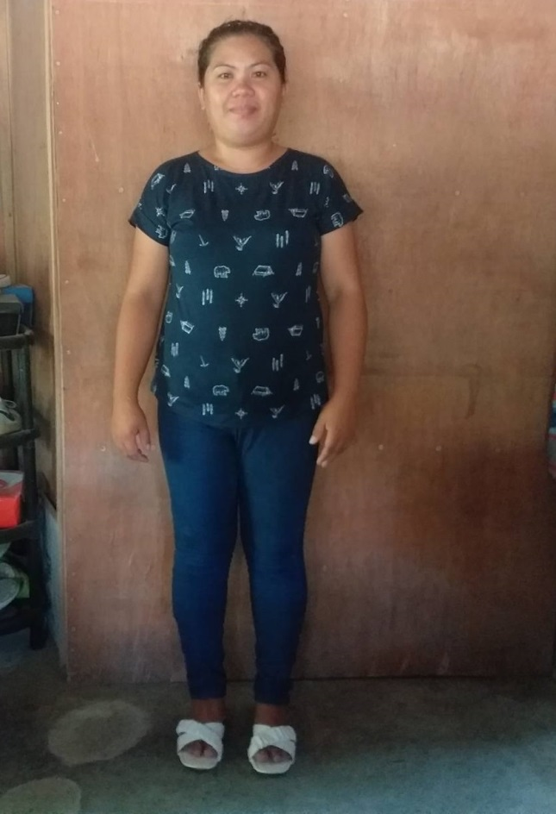
練習 TRAINING

國 內 經 歷 LOCAL EMPLOYMENT RECORD
工作期間  Month / day / year  From --- To |  |  | 雇主  EMPLOYER |  |  |  |  |  |  | 職務  JOB TITLE

國 外 經 歷 OVERSEAS EMPLOYMENT RECORD
工作期間  Month / day / year  From --- To |  | 國家COUNTRY  雇主EMPLOYER |  |  |  |  |  |  |  | 職務  JOB TITLE
12/05/2017 – 12/05/2019 |  | KUWAIT |  |  |  |  |  |  |  | DOMESTIC WORKER
PASSPORT |  |  |  | TRAINING |  |  |  |  |  |  | UMID |  | NBI |  |  |  | MEDICAL |  |  | TRAVEL HISTORY
OK |  |  |  | NCII DOMESTIC WORKER |  |  |  |  |  |  | OK |  | OK |  |  |  | OK
CONTACT NUMBER: 09278024853
FACEBOOK ACCOUNT: AYOJ DATNAB

FAMILY BACKGROUND 家 庭 狀 況
親屬關係Relation | 姓 名  Name | 年齡  Age | 職業  Occupation | 備註  Remarks
父親Father | JERO L. ENRIQUEZ | 59 | CARPENTER
母親Mother | SUSEMA O. ENRIQUEZ | 54 | HOUSEWIFE
配偶Spouse | RAYMUND A. BANTAD | 38 | SECURITY GUARD
其他Others /  CHILDREN’s | LESTER JAY E. BANTAD | 15 | STUDENT
 | RENZ JAKE E. BANTAD | 7 | STUDENT

DATE APPLIED: 15 AUGUST 2022

