PERSONAL PARTICULARS

CARETAKER

姓名  NAME | LENY D. TUMOMBA |  |  |  |  |  |  |  |  |  |  |  |  |  |  |  |  |  |  |  |  | H-707
地址  ADDRESS | EMR COMP. LAGMAY BRGY. SAN JOSE DASMA CITY |  |  |  |  |  |  |  |  |  |  |  |  |  |  |  |  |  | 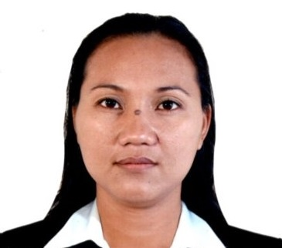
年齡  AGE –40 | 占星術  Horoscope |  |  |  |  |  |  |  | 出生日期  BIRTH DATE |  |  |  |  | DEC. 31,1984
性別  SEX | FEMALE |  |  |  |  |  |  | 出生地點  PLACE OF BIRTH |  |  |  |  |  | CAVITE
國籍  NATIONALITY | FILIPINO |  |  |  |  |  |  | 宗教信仰  RELIGION |  |  |  |  |  | ROMAN CATHOLIC
身高  HEIGHT (CM) | 157 |  |  |  |  |  |  | 體重  WEIGHT (KG) |  |  |  |  |  | 58
特別技能  SKILL | HARDWORKING |  |  |  |  |  |  |  |  |  |  |  |  |  |  |  |  |  | 語言  LANGUAGE |  |  |  | ENGLISH/ TAGALOG
婚姻狀況  CIVIL STATUS |  |  |  |  | 未婚  SINGLE |  |  |  |  |  |  | 已婚  MARRIED |  |  |  |  |  | 離異  SEPARATED |  |  |  |  | 寡居  WIDOWED
教育程度  EDUCATION |  |  |  |  | 小學  ELEMENTARY |  |  |  |  |  |  | 中學  HIGHSCHOOL |  |  |  |  |  | 大學  COLLEGE |  |  |  |  | 專科  VOCATIONAL
學校名稱  NAME OF SCHOOL LAST ATTENDED |  |  |  |  |  |  |  | DASMARINAS EAST NATIONAL HIGH SCHOOL
主修 COURSE |  |  |  |  |  |  |  |  |  |  |  |  |  |  | 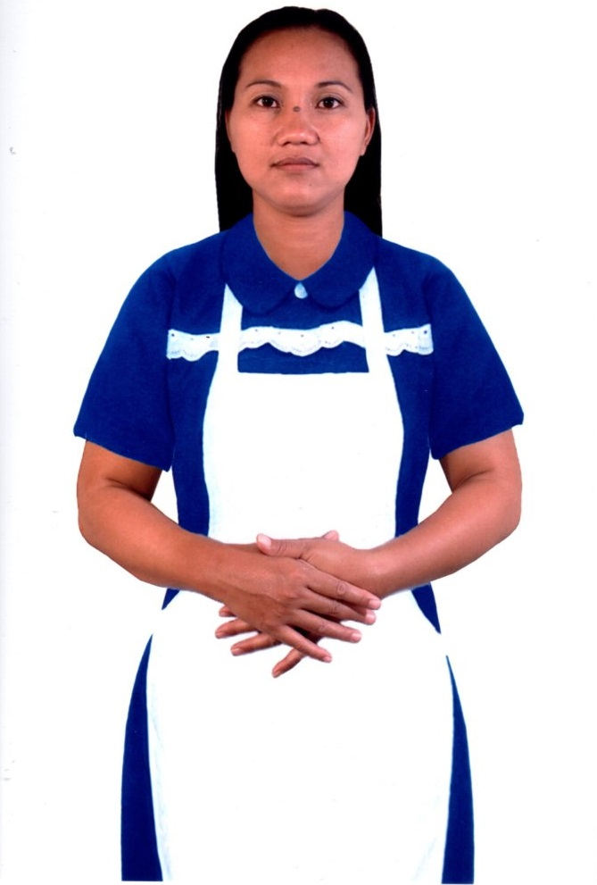
練習 TRAINING

國 內 經 歷 LOCAL EMPLOYMENT RECORD
工作期間  Month / day / year  From --- To |  |  | 雇主  EMPLOYER |  |  |  |  |  |  | 職務  JOB TITLE
2019-2021 |  |  | REN- A MARK |  |  |  |  |  |  | WAREHOUSE STAFF
2005-2006 |  |  | ANNIES CANDY MANUFACTURE |  |  |  |  |  |  | MACHINE OPERATOR

國 外 經 歷 OVERSEAS EMPLOYMENT RECORD
工作期間  Month / day / year  From --- To |  | 國家COUNTRY  雇主EMPLOYER |  |  |  |  |  |  |  | 職務  JOB TITLE
2014 |  | TAIWAN |  |  |  |  |  |  |  | CARETAKER
PASSPORT |  |  |  | TRAINING |  |  |  |  |  |  | UMID |  | NBI |  |  |  | MEDICAL |  |  | TRAVEL HISTORY
OK |  |  |  |  |  |  |  |  |  |  | OK |  | OK
CONTACT NUMBER: 09754973009
FACEBOOK ACCOUNT: LHENNYDUA

FAMILY BACKGROUND 家 庭 狀 況
親屬關係Relation | 姓 名  Name | 年齡  Age | 職業  Occupation | 備註  Remarks
父親Father | SILVESTRE DUA |  |  | DECEASE
母親Mother | DELIA DUA | 67 | HOUSEWIFE
配偶Spouse | DENNIS TUMOMBA
其他Others /  CHILDREN’s | FRANK DHYNEL D. TUMOMBA  ASHLEY D. MANRIQUE  CLARKSON REX D. MANRIQUE | 17  13  07 | STUDENTS

DATE APPLIED: APRIL 28,2023

