PERSONAL PARTICULARS

CARETAKER

姓名  NAME | GLYSA LOZADA |  |  |  |  |  |  |  |  |  |  |  |  |  |  |  |  |  |  |  |  | H-747
地址  ADDRESS | EMR COMP. SAN JOSE DASMA CAVITE |  |  |  |  |  |  |  |  |  |  |  |  |  |  |  |  |  | 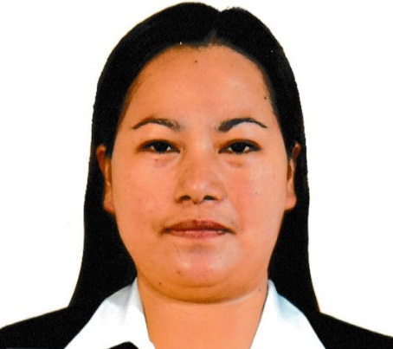
年齡  AGE –38 | 占星術  Horoscope |  |  |  |  |  |  |  | 出生日期  BIRTH DATE |  |  |  |  | AUG. 15, 1984
性別  SEX | FEMALE |  |  |  |  |  |  | 出生地點  PLACE OF BIRTH |  |  |  |  |  | DASMA CAVITE
國籍  NATIONALITY | FILIPINO |  |  |  |  |  |  | 宗教信仰  RELIGION |  |  |  |  |  | ROMAN CATHOLIC
身高  HEIGHT (CM) | 154 |  |  |  |  |  |  | 體重  WEIGHT (KG) |  |  |  |  |  | 60
特別技能  SKILL | HARDWORKING |  |  |  |  |  |  |  |  |  |  |  |  |  |  |  |  |  | 語言  LANGUAGE |  |  |  | ENGLISH/ TAGALOG
婚姻狀況  CIVIL STATUS |  |  |  |  | 未婚  SINGLE |  |  |  |  |  |  | 已婚  MARRIED |  |  |  |  |  | 離異  SEPARATED |  |  |  |  | 寡居  WIDOWED
教育程度  EDUCATION |  |  |  |  | 小學  ELEMENTARY |  |  |  |  |  |  | 中學  HIGHSCHOOL |  |  |  |  |  | 大學  COLLEGE |  |  |  |  | 專科  VOCATIONAL
學校名稱  NAME OF SCHOOL LAST ATTENDED |  |  |  |  |  |  |  | IMUS NATIONAL HIGH SCHOOL
主修 COURSE |  |  |  |  |  |  |  |  |  |  |  |  |  |  | 
練習 TRAINING

國 內 經 歷 LOCAL EMPLOYMENT RECORD
工作期間  Month / day / year  From --- To |  |  | 雇主  EMPLOYER |  |  |  |  |  |  | 職務  JOB TITLE
02-20-2007 |  |  | MAGNOLIA |  |  |  |  |  |  | PACKER
03-05-2005 |  |  | USHIO |  |  |  |  |  |  | MARKER

國 外 經 歷 OVERSEAS EMPLOYMENT RECORD
工作期間  Month / day / year  From --- To |  | 國家COUNTRY  雇主EMPLOYER |  |  |  |  |  |  |  | 職務  JOB TITLE
06-21-2017  10-27-2022 |  | TAIWAN |  |  |  |  |  |  |  | CARETAKER (TAKING CARE OF ELDERLY, 82 YRS OLD, 70 KG, CHANGING DIAPER, BED BATH, GO TO MARKET, LAUNDRY)
PASSPORT |  |  |  | TRAINING |  |  |  |  |  |  | UMID |  | NBI |  |  |  | MEDICAL |  |  | TRAVEL HISTORY
OK |  |  |  |  |  |  |  |  |  |  | OK
CONTACT NUMBER: 09770177809
FACEBOOK ACCOUNT: GOMEZ GLYSA

FAMILY BACKGROUND 家 庭 狀 況
親屬關係Relation | 姓 名  Name | 年齡  Age | 職業  Occupation | 備註  Remarks
父親Father | FRED GOMEZ | 64 | CARPENTER
母親Mother | PACITA GOMEZ | 65 | HOUSEWIFE
配偶Spouse | JAIRUS CYRIL LOZADA | 36 | SALES MARKETING
其他Others /  CHILDREN’s | XYZA CYRUS LOZADA  GHLEZIE GWYNET LOZADA | 11  15

