PERSONAL PARTICULARS
 | CARETAKER |  | MS

姓名  NAME | AIRYN MAE D.MARAMARA |  |  |  |  |  |  |  |  |  |  |  |  |  |  |  |  |  |  |  |  | JMH-676
地址  ADDRESS | SITIO TAMBIS,YATI LILOAN CEBU |  |  |  |  |  |  |  |  |  |  |  |  |  |  |  |  |  | 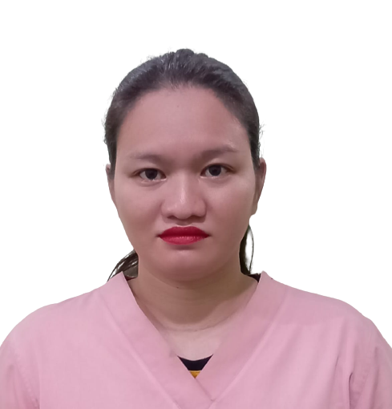
年齡  AGE – 32 | 占星術  Horoscope |  |  |  |  |  |  |  | 出生日期  BIRTH DATE |  |  |  |  | FEB 12 1990
性別  SEX | FEMALE |  |  |  |  |  |  | 出生地點  PLACE OF BIRTH |  |  |  |  |  | TUOD MANTICAO MISAMIS ORRIENTAL
國籍  NATIONALITY | FILIPINO |  |  |  |  |  |  | 宗教信仰  RELIGION |  |  |  |  |  | ROMAN CATHOLIC
身高  HEIGHT (CM) | 157 |  |  |  |  |  |  | 體重  WEIGHT (KG) |  |  |  |  |  | 58KLS
特別技能  SKILL | HARDWORKING |  |  |  |  |  |  |  |  |  |  |  |  |  |  |  |  |  | 語言  LANGUAGE |  |  |  | ENGLISH/ TAGALOG
婚姻狀況  CIVIL STATUS |  |  |  |  | 未婚  SINGLE |  |  |  |  |  |  | 已婚  MARRIED |  |  |  |  |  | 離異  SEPARATED |  |  |  |  | 寡居  WIDOWED
教育程度  EDUCATION |  |  |  |  | 小學  ELEMENTARY |  |  |  |  |  |  | 中學  HIGHSCHOOL |  |  |  |  |  | 大學  COLLEGE |  |  |  |  | 專科  VOCATIONAL

學校名稱

NAME OF SCHOOL LAST ATTENDED
主修 COURSE |  |  |  |  |  |  |  |  |  |  |  |  |  |  | 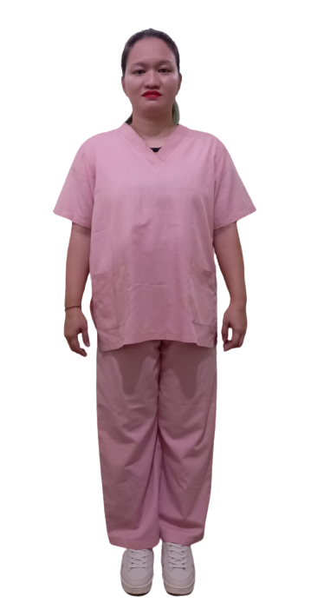
練習 TRAINING

國 內 經 歷 LOCAL EMPLOYMENT RECORD
工作期間  Month / day / year  From --- To |  |  | 雇主  EMPLOYER |  |  |  |  |  |  | 職務  JOB TITLE
2011-2013 |  |  | PALMPHIL GARMENTS PHILS.CORP |  |  |  |  |  |  | EMBROIDERY QC
2013-2014 |  |  | MONDE NISSIN CORPORATION |  |  |  |  |  |  | PRODUCTION OPERATOR
2017-2020 |  |  | LOPEZ |  |  |  |  |  |  | CARETAKER
2021-2023 |  |  | SHAWTY |  |  |  |  |  |  | HOUSEKEEPER

國 外 經 歷 OVERSEAS EMPLOYMENT RECORD
工作期間  Month / day / year  From --- To |  | 國家COUNTRY  雇主EMPLOYER |  |  |  |  |  |  |  | 職務  JOB TITLE
PASSPORT |  |  |  | TRAINING |  |  |  |  |  |  | UMID |  | NBI |  |  |  | MEDICAL |  |  | TRAVEL HISTORY
OK |  |  |  |  |  |  |  |  |  |  | OK |  | OK
CONTACT NUMBER: 09100399796
FACEBOOK ACCOUNT: MISTIQUE-YHEN@YAHOO.COM

FAMILY BACKGROUND 家 庭 狀 況
親屬關係Relation | 姓 名  Name | 年齡  Age | 職業  Occupation | 備註  Remarks
父親Father | ISRAEL S. MARAMARA | 52
母親Mother | MERCY BETH MARAMARA | 52
配偶Spouse
其他Others /  CHILDREN’s | AJ M. LLENES  Yassie M. LLANES | 5  3

DATE APPLIED: ___01-18-2023_____________________

