Unit 201 Estrella Condominium 858 San Andres St. Brgy 725 Malate, Manila

PERSONAL PARTICULARS
 | CARETAKER |  |  | MS

姓名  NAME | SHEILA S. SAMONTE |  |  |  |  |  |  |  |  |  |  |  |  |  |  |  |  |  |  |  |  | JMH-661
地址  ADDRESS | P30 FRANCISCO LANGON TUNGAWAN ZAMBOANGA DEL SUR |  |  |  |  |  |  |  |  |  |  |  |  |  |  |  |  |  | 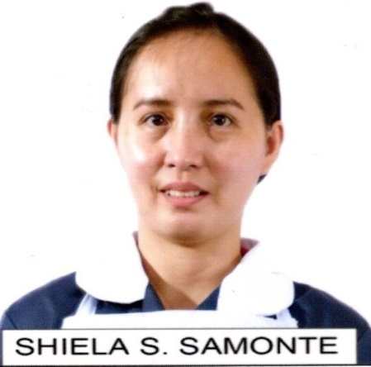
年齡  AGE – 33 | 占星術  Horoscope |  |  |  |  |  | SCORPIO |  | 出生日期  BIRTH DATE |  |  |  |  | 29 OCT 1989
性別  SEX | FEMALE |  |  |  |  |  |  | 出生地點  PLACE OF BIRTH |  |  |  |  |  | TUNGAWAN ZAMBOANGA DEL SUR
國籍  NATIONALITY | FILIPINO |  |  |  |  |  |  | 宗教信仰  RELIGION |  |  |  |  |  | ALLIANCE
身高  HEIGHT (CM) | 160 |  |  |  |  |  |  | 體重  WEIGHT (KG) |  |  |  |  |  | 60
特別技能  SKILL | HARDWORKING |  |  |  |  |  |  |  |  |  |  |  |  |  |  |  |  |  | 語言  LANGUAGE |  |  |  | ENGLISH/ TAGALOG
婚姻狀況  CIVIL STATUS |  |  |  |  | 未婚  SINGLE |  |  |  |  |  |  | 已婚  MARRIED |  |  |  |  |  | 離異  SEPARATED |  |  |  |  | 寡居  WIDOWED
教育程度  EDUCATION |  |  |  |  | 小學  ELEMENTARY |  |  |  |  |  |  | 中學  HIGHSCHOOL |  |  |  |  |  | 大學  COLLEGE |  |  |  |  | 專科  VOCATIONAL
學校名稱  NAME OF SCHOOL LAST ATTENDED |  |  |  |  |  |  |  | GOVERNOR ALFONSO D. TAN COLLEGES
主修 COURSE |  |  |  |  |  | COMPUTER SCIENCE |  |  |  |  |  |  |  |  | 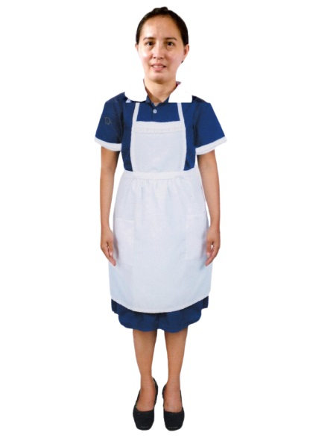
練習 TRAINING

國 內 經 歷 LOCAL EMPLOYMENT RECORD
工作期間  Month / day / year  From --- To |  |  | 雇主  EMPLOYER |  |  |  |  |  |  | 職務  JOB TITLE
2013–2014 |  |  | ADELINA FERRER |  |  |  |  |  |  | CARETAKER
2017-2020 |  |  | LAYLA |  |  |  |  |  |  | BABYSITTER
2021-2022 |  |  | DUTCH |  |  |  |  |  |  | HOUSEKEEPING

國 外 經 歷 OVERSEAS EMPLOYMENT RECORD
工作期間  Month / day / year  From --- To |  | 國家COUNTRY  雇主EMPLOYER |  |  |  |  |  |  |  | 職務  JOB TITLE
PASSPORT |  |  |  | TRAINING |  |  |  |  |  |  | UMID |  | NBI |  |  |  | MEDICAL |  |  | TRAVEL HISTORY
OK |  |  |  | OK |  |  |  |  |  |  | OK |  | OK |  |  |  | FIT TO WORK |  |  | OK
CONTACT NUMBER: 09678406506
FACEBOOK ACCOUNT: SHEILA SAMONTE

FAMILY BACKGROUND 家 庭 狀 況
親屬關係Relation | 姓 名  Name | 年齡  Age | 職業  Occupation | 備註  Remarks
父親Father | REYNALDO V. SAMONTE | 53 | FARMER
母親Mother | ELIZABETH S. SAMONTE | 50 | HOUSEWIFE
配偶Spouse
其他Others /
CHILDREN’s

DATE APPLIED: 22 SEPTEMBER 2022

